Chapter 10, Problem 55.

Find the Thevenin and Norton equivalent circuits at terminals a-b for each of the circuits in Fig. 10.98.
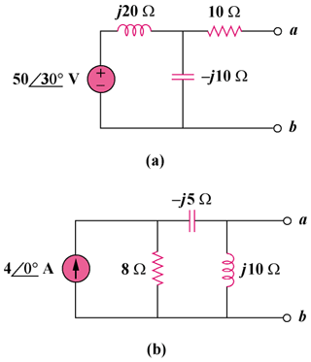

Figure 10.98
For Prob. 10.55.

